**Activation Records & Links** –Fill in the static and dynamic links for the activation records on the run-time stack, working from top to bottom. Label each record with the function name.

M

Static Link

Dynamic Link

Subprogram M

const

a=93

var

x,y

Subprogram N(w)

const

b

var

y,z

Subprogram P(i)

const

a,c

var

x

begin

x=i

if x mod 2 = 1

N(x+1)

end

Subprogram Q

var

x

begin

P(i)

x=y+a

end

begin //N

P(w)

y=8

end

begin //M

Q()

end

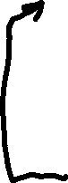

Static Link

Dynamic Link

Q

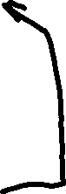

Static Link

Dynamic Link

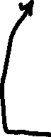

Static Link

Dynamic Link

Static Link

Dynamic Link