HP Z6200 Printer User Manual
Kutztown University of Pennsylvania | CSIT Department
Connecting and Printer to Plotter printer

*Adapted from previous manuals*
2022
Table of Contents
The Printer 2
Creating the Poster Board 3
Printing the Poster Board 5

The Printer

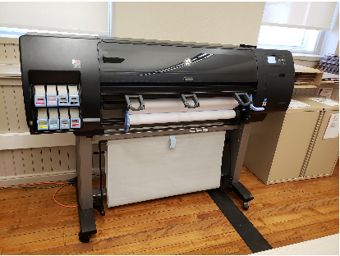
Figure 1: Plotter Printer
The printer that you will be using is the plotter printer in Old Main Roo m156 (OM156). This printer is labelled as the 42-inch HP DesignJet Z6200 Photo Production Printer. This printer does not get used very often and tends to have issues because of this. The ink has an expiration period of 30 months, and the printer will throw an error for this when the time is up. You can still print if it is expired most of the time. Asking the CSIT Department Secretary for help using the printer is the best way to keep it working and free from unnecessary damage and alterations. Requesting help from IT is also a viable option. DO NOT; REPEAT DO NOT attempt a repair if you are unsure. You can damage this printer and it is not cheap to fix and replace parts!
If something in the printer needs to be replaced, maintained or changed (such as ink cartridges, paper, etc.), again, ask the CSIT Secretary for assistance for any of this.

Creating the Poster Board

The poster board must be 35 inches high by 48 inches wide. We have a 42-inch max width print but currently there is 36-inch paper in it so you must have these specifications correct. You can use tri-fold templates in Word or Pages or Adobe Photoshop.
We have used Adobe Photoshop to create our poster:
- Launch Adobe Photoshop
- Click on file new
- Update the width to 48 inches and the height to 35 inches. Keep the resolution at 300pixels.
- Give your file a name too.
- Click on Create at the bottom right. You now have a blank canvas.
- You will want to add grid lines to indicate the trifold poster.
  - Click View -> New Guide
  - Add a vertical guide at 12 inches and 36 inches.
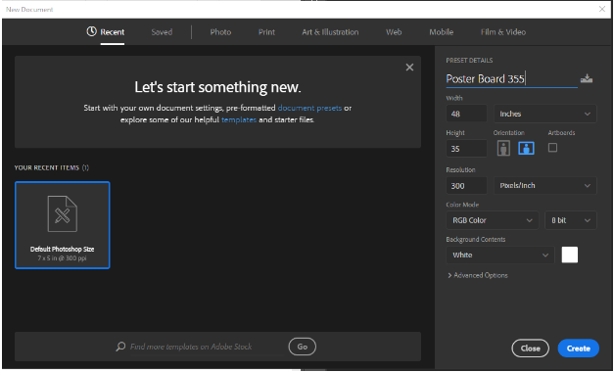
  - You now have a blank poster board.
Figure 2: Adobe Photoshop New

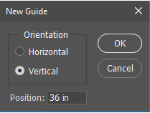
Figure 3:Dimensions
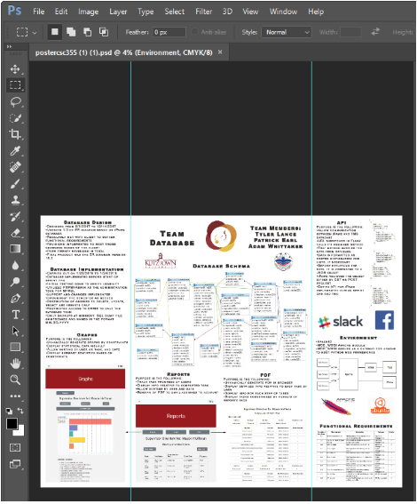
Figure 4: Guides and template

Printing the Poster Board

The HP Click Utility prints certain file formats (jpg, jpeg, png, tiff, pdf, and hpgl2). It is recommended to use jpeg.
You will be able to print from the computers in OM156 on the left as you walk in. These are the only computers in OM156 that will print to the Plotter Printer. The others are used for networking and will not find the printer.

Make sure that the printer is turned on before you try and print to it. There is a startup process that it needs to go through before it is ready to receive print jobs. The paper in the printer will slide back and forth, coming in and out of the machine. Do not interrupt this process as this is the printer confirmed that the paper run is still good. Once the movement has stopped and there are no signals on the printer, follow the steps below to print your poster:

- Once the poster is complete, if a white background is desired, go to the background layer, it will be the first one. Select the eye icon on that layer and a checkboard-like pattern will appear as the background.
- Select “File” in the top left corner and go to the bottom of the menu and select “Print”.
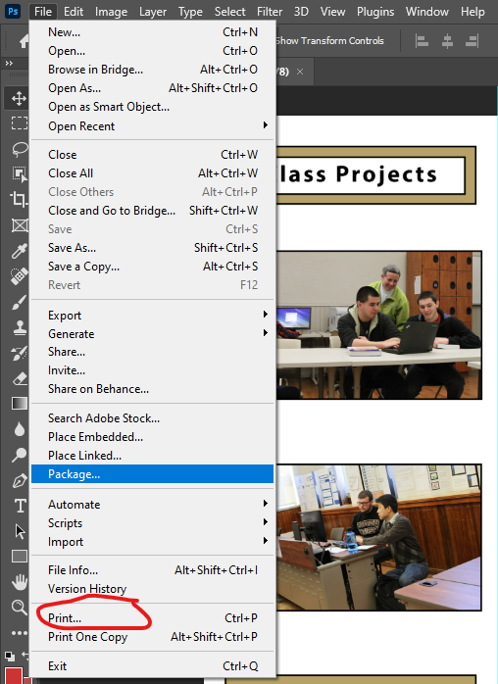
- IMPORTANT: Make sure the selected printer is “OM156_PLOTTER”
- Once selected, scroll down to “Scaled Print Size” and check the paper size:

  - If a preview of the document needs to be printed from the plotter, select LETTER. This is size 8.5" x 11", most likely the default size.
  - If the bigger poster needs to be printed, select “Print Settings” at the top of the window. In the menu select “Custom” to make the width, 36 inches, and the length, 48 inches. Create a name for the dimensions, ex: “Posterboard-CSIT”, and select “Save”, then “Ok”. At the bottom of the window select “Ok” to confirm the desired paper size.

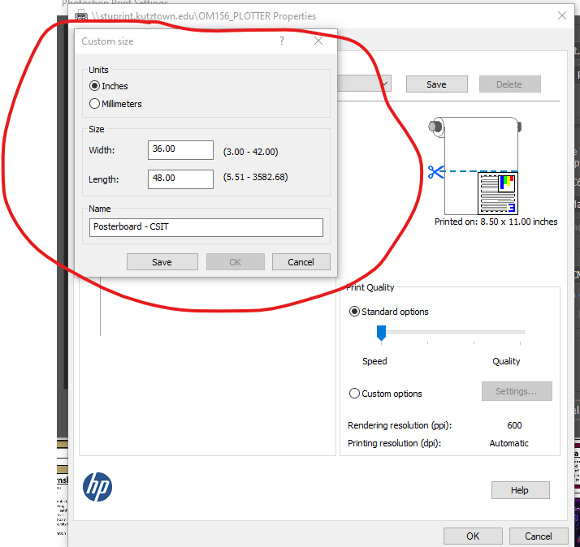

- Adjust the layout to horizontal
- Under the section “Color Management” and under “Color handling”
make sure the drop box has “Printer Manages Colors” selected

- Under the section “Position and Size” center your work to the page

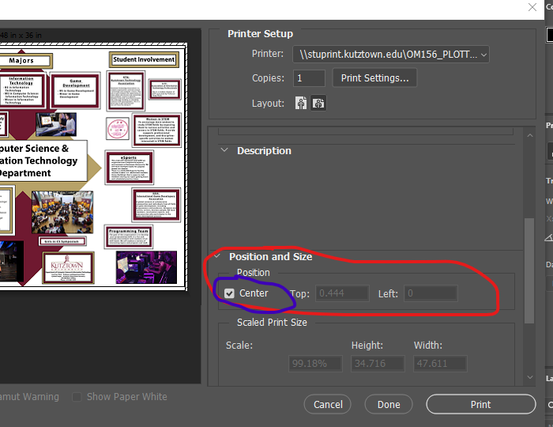

- Under the section “Scaled Print Size” check the box that says “Scale to Fit Media”

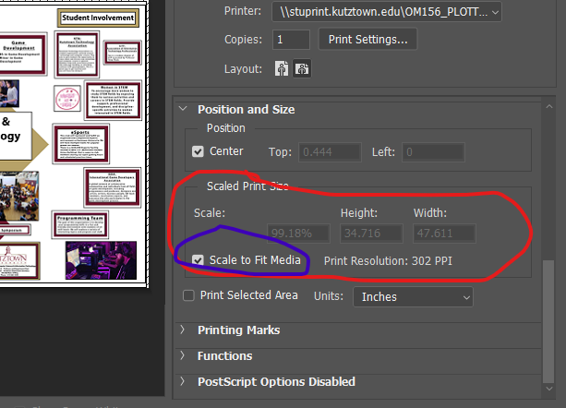
- MAKE SURE THE PRINTER IS ON AND ANY SET UP MOVEMENTS ARE COMPLETE BEFORE YOU PRINT.
- Select “Print” at the bottom of the window, there will be one more pop-up window, select “Print” once more.
- Please be patient, it takes a few minutes for the printing to start. Wait until the printer cuts the paper & the poster falls into the bottom catch before retrieving your poster. Do not try to pull the paper out of the printer

