CSC 363 Interdisciplinary Rapid Software Prototyping, Spring 2020
Dr. Dale E. Parson, CSC Assignment 1, Writing a Project Plan.

Assignment is due via D2L by 11:59 PM on Friday February 14, also a peer eval per the final page.

Replace my sections below. Create a document entitled Project Plan with your team / project name and team member names, using the format of this Word document. Create a section for each CSC student, and attach the student name to that section. A given student may write more than 1 section as needed. After each student writes 1 section, you may collaborate in pairs on other sections; tag those sections with the names of the contributing students. Turn this in via a D2L Assessments -> Assignments -> assignment 1 page by the end of February 14. Turn in only one copy per team. Save this as Word document with the default .docx format and turn in that file. 45% of the CSIT grading for this is per student section, and 45% per team, with 10% per peer evaluation on the final page. CDE students will also supply evaluations for their CSIT teammates. Peer evaluations will count more than 10% in later deliverables. This is the only spec this semester. The remainder consists of demos, code, per evals, and the final installation or demo.

Each of you must also return a hard copy on February 14 or send email to parson@kutztown.edu by the end of that day, ranking the contribution of each of your team peers on a scale of 0 through 10. Do not rank yourself. Read the form on the last page.

I am not setting a page count requirement, but I will deduct points from anemic sections that are not substantial and clear, or that leave big gaps in the reader’s picture of the system and work.

Section 1 List and describe 3 to 6 primary features. Describe them adequately so I can understand them. You can have additional minor features. List and describe those as well. Use illustrations supplied by your CDE team partners. Add your own illustrations if appropriate. I should know what my experience as a user will be. You should break Section 1 into subsections, e.g., 1.1, 1.2, etc., and you may have different students write different subsections. The same optional breakdown applies to the remaining Sections.

Section 2 List and describe the risks associated with the project, including personnel (inadequate or poorly matched team personnel), resources (unverified code libraries, delivery platforms, and others), and schedule risks. Describe means for eliminating or mitigating these risks, such as feature reduction or working around problems. There may be other means. There should be at least one entry per feature of Section 1, even if the risk is “none”. For any imported code library that carry risks, begin at least preliminary use of the library for evaluation, and document your work and findings.

Section 3 Summarize a test plan that gives automated (if any) or manual (likely) steps for testing components and the entire system. Since it is not yet constructed, this will not be overly detailed, and GUI interactions are likely to change, but give enough detail so that a GUI tester or test-user sitting down with the proposed system could actually walk through interactions in a manual test of the system. If you are performing some non-GUI, automated tests, describe how they will test features and how you will implement them. There must be at least one entry per feature of Section 1.

Section 4 Define the Work Breakdown Structure (WBS) for your project as defined on the next page. Make sure to illustrate the Task (dependency) Network, including annotated effort-times, and planned team members on those task bubbles where known. Make your best effort of estimates. The WBS shows the tasks that team members will perform, time estimates in days, and the name or names of students performing each task.

Work Breakdown Structure (WBS)

- 1. Determine deliverables.
- 2. Identify steps & tasks to produce each; include subtasks.
- 3. Sequence the tasks; identify opportunities for parallel development.
- 4. Estimate effort for each task in weeks of time.
- 5. Attach the planned name(s) for each task, if you know who may work on it.
- 6. Lay out the timeline & label resources assigned to each task.
  - See diagram below.

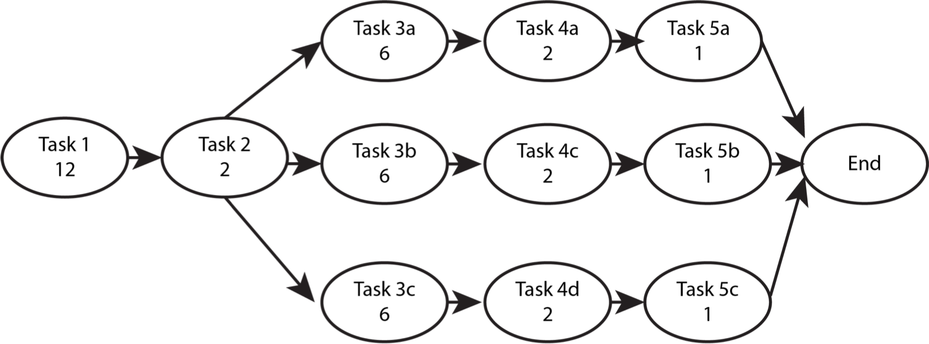
WBS, estimated time in weeks. Attach names of team members where known.
CSC 363 Interdisciplinary Rapid Software Prototyping, Spring 2020, Peer Review

For assignment 1 that is due on February 14, list each of your teammates (not yourself), and rank their contribution on this part of the assignment, on a scale of 0 (no contribution) to 10 (maximum contribution). Explain any that go below 7.5. If you feel that you are being ostracized from the group, or your skills are not a good match for the assignment, let me know that on the back of this sheet or in the email. You can turn this section in via secure email if you prefer. Use your KU email account. Do not rank yourself. This review is worth 10% of the project grade. It will be worth more on each deliverable.

(Your name printed & date)

____________________________________ __________________________________
Team member Ranking 0..10
Comments regarding team member if below 7.5

____________________________________ __________________________________
Team member Ranking 0..10
Comments regarding team member if below 7.5

____________________________________ __________________________________
Team member Ranking 0..10
Comments regarding team member if below 7.5

